Hierarchy Example
by Vadim Mutilin (mutilin@ispras.ru)
Institute for System Programming, Russian Academy of Sciences

System description
We have a set of company trees. Each company has name, parent company, a list of children and status active/inactive.
If parent is null then company is root of the tree. If company has no children then it is leaf.
We can manage hierarchies by using the following methods:
- boolean setParent(Company newParent) – sets a new parent. Returns true if operation succeeds.
- boolean setActive() – changes company status to active. Returns true if operation succeeds.
- boolean setInactive() – changes company status to inactive. Returns true if operation succeeds.
We have a business rule for the hierarchies: Active company cannot have inactive parent.
Figure shows an example of violation of the rule: Company C₂ has inactive parent C₁.
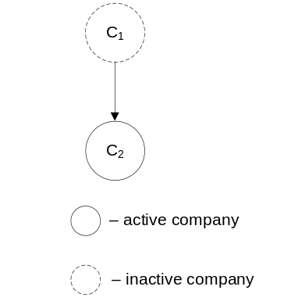

Test case
For the test purpose we have created two companies with active status: Rosneft and Gazprom. Test case consists of creating two threads. First thread invokes method setParent. It sets Gazprom as parent company for Rosneft. Second thread invokes setInactive. It changes status of Gazprom to inactive. According to the rule either setParent or setInactive must return false result, because the hierarchy shown in the following figure violates the rule.
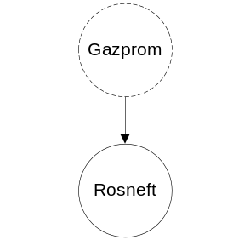

Bug
Incorrect synchronization leads to the bug. In the example we have synchronized access to this object, but it is not sufficient to safely change parent of the company. At least we need to synchronize on the new parent.
If the output of the program is «Hierarchy rule is true» then the rule was not violated. Otherwise, it was violated.

